From now on we will not be giving you step by step instructions. Using your past projects and the internet you will use the minimal instructions we give you to create your own compositions just like a graphic artist would.
The internet is a wonderful place for finding tutorials in Photoshop! Use your resources. Below is a good example of a great site for neat effects!
http://www.good-tutorials.com/tutorials/photoshop

We want to see what you can do!

Lesson 1
3 part project ~logo mascot/ city crest or emblem/ business slogan and logo

Part 1
First you need to choose a random or interesting city and state. You need to create a sports team, any team from football to roller derby for your city.
We want you to create a new logo and mascot name in Photoshop. Below are examples of different team names and their logo. The logo can be as abstract or detailed as you would like it.
Logos/mascot
examples
- Bowling Green state University, Falcons
Logo
- Cleveland, Indians World Cup
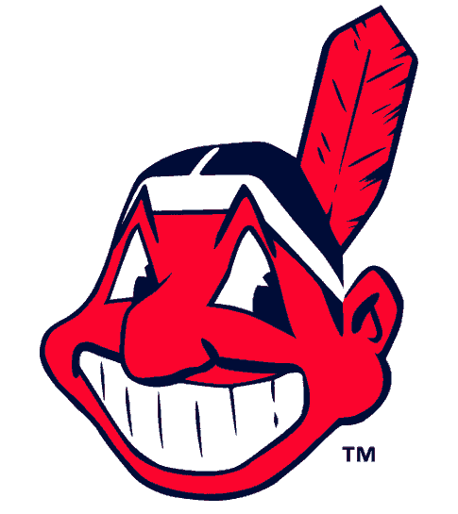Logo 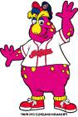Mascot “Slider”
- Philadelphia, Phillies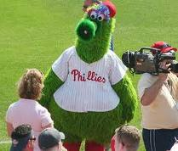 mascot “Phanatic”

Part 2

Using the same city and state create a crest or emblem that signifies what the city is about. Choose your own shape and symbols to create this.

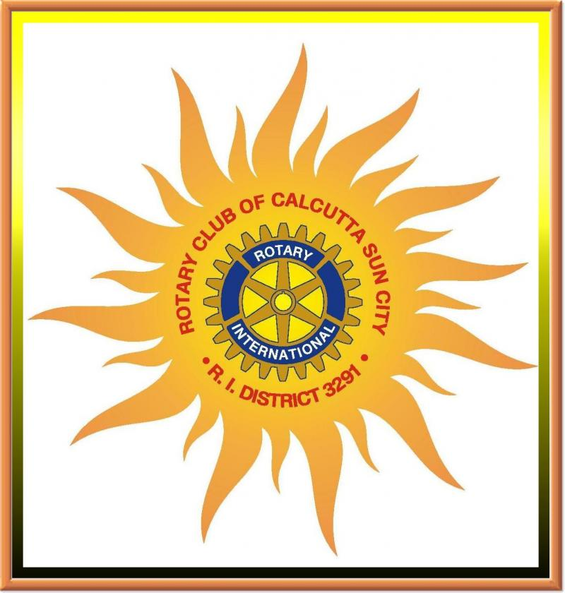
Crest/Emblem
Examples

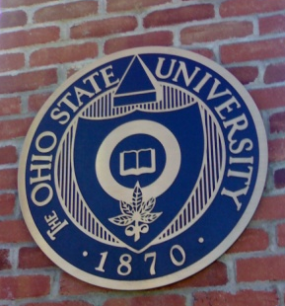OSU

Part 3
Using the same city again create a business that would thrive in this metropolis. You need a slogan and a logo to put on your letter head, business cards and envelops.
Create the shape of your letter head, business cards and envelops and place the design on them like a real business would. These should be on one page 11 x 17.

Slogan
examples
- “Just do it” Nike
- 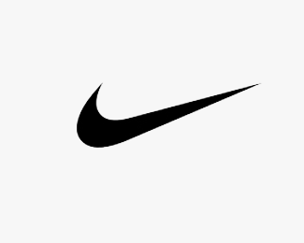
- “Have it your way” Burger King
- 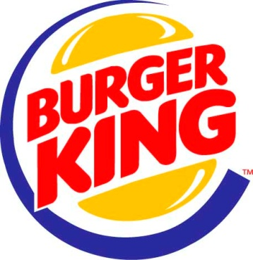

- “Rule the Air” Verizon

- “Fly the friendly skies” United Airlines
